
Reka Bentuk Antara Muka Berasaskan Web
(CSF3133)

LAB REPORT 5

NAME: CHIA FU YAN
MATRIC: S75039
DATE: 19/11/2024
GROUP: K4
PROGRAM: Computer Science (Software Engineering)
LECTURER: Miss Wan Fatin

5.3 Inline CSS
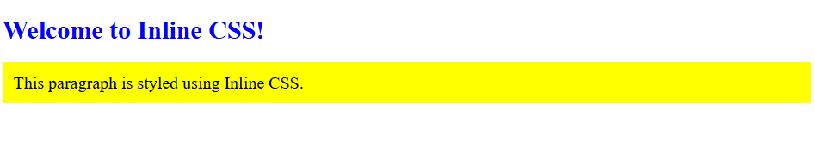

5.4 Internal CSS
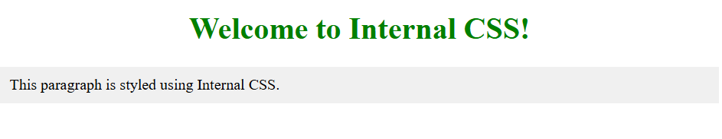

5.5 External CSS
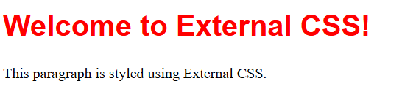

5.6 Link to File CSS (from another website)
Step 2
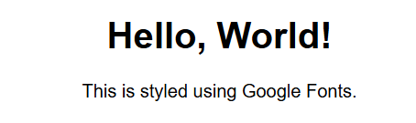

Step 5
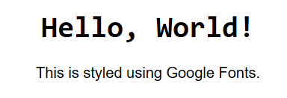

5.7 CSS Backgrounds
Step 3
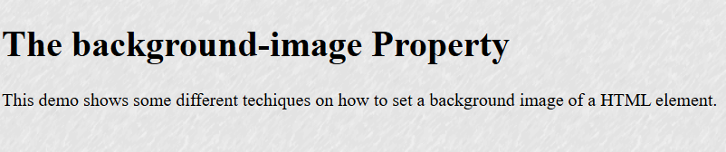

Step 6
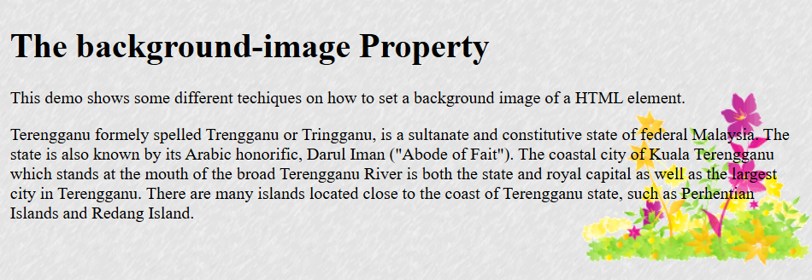

5.8 CSS Table
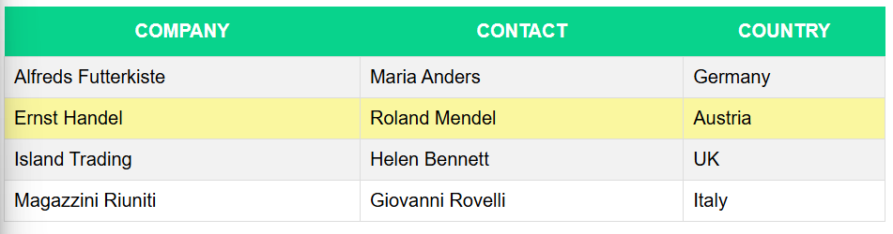

5.9 CSS Navigation Bar

Step 3
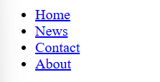
Step 5
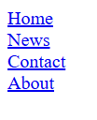
Step 7
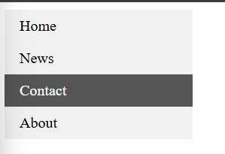
Step 9


5.10 Lab Exercise 5
Source Code
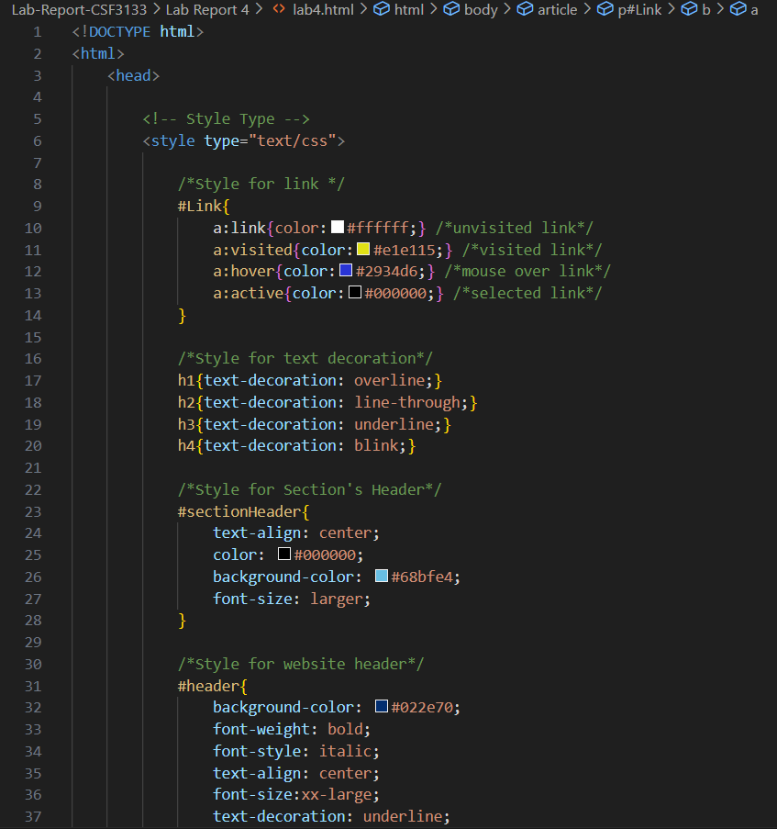
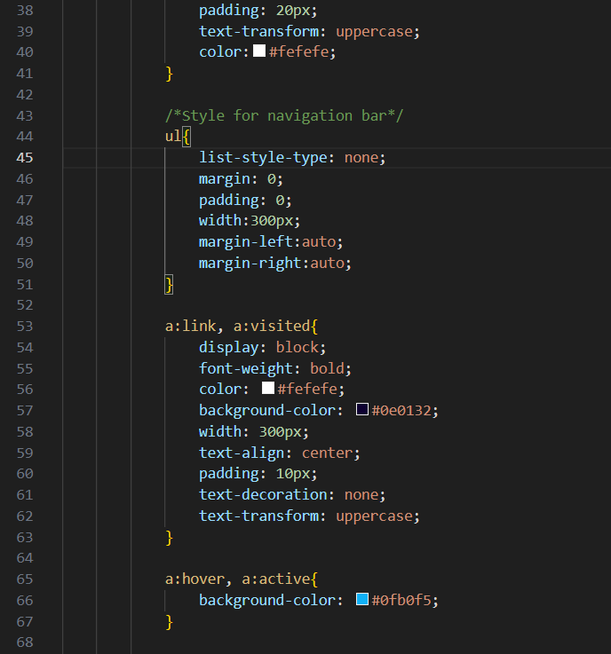
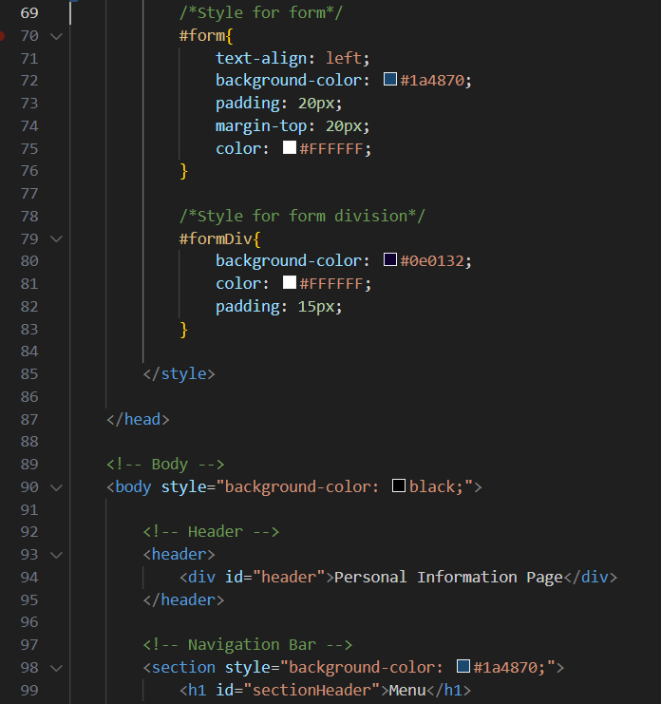
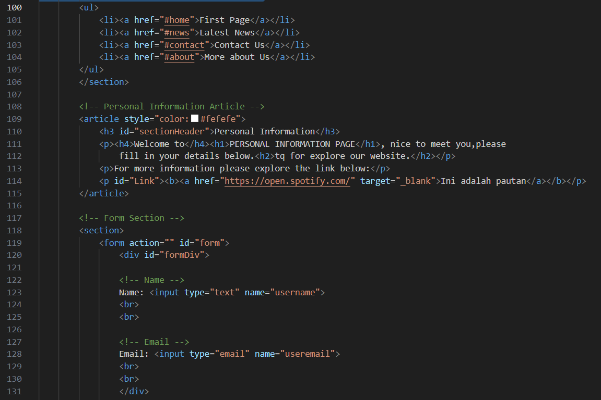
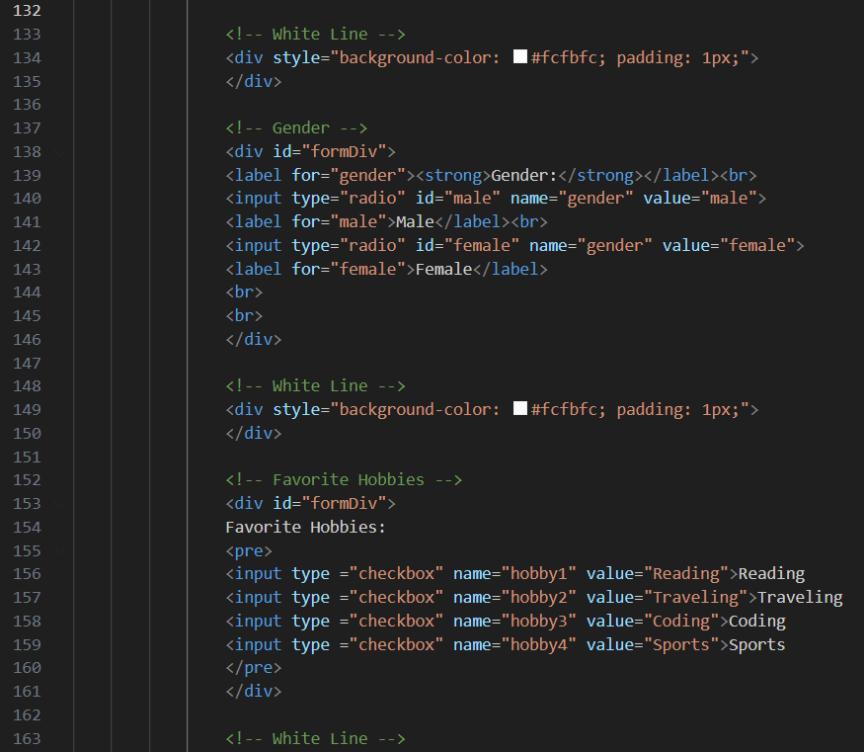
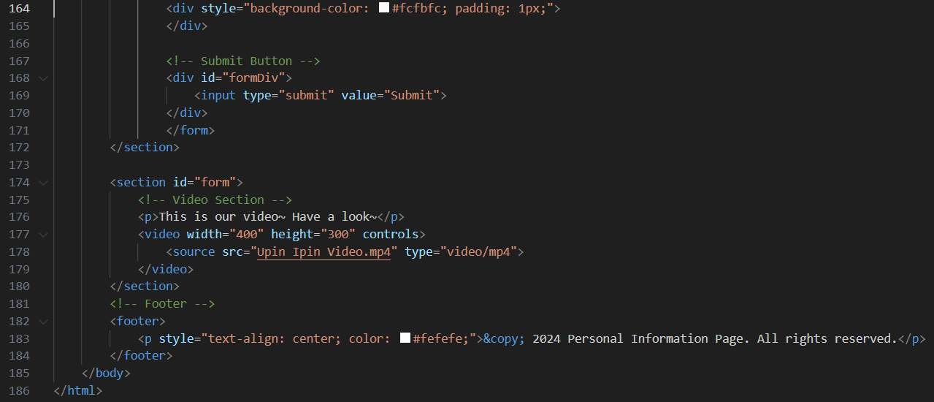
Output
